|  |  |
| --- | --- |
|  |  |

**Impact of Wastewater from Sugar and Fertilizer Industries on Ghotki Feeder and Agricultural Fields**

Shoukat Ali Soomro, Qarar Hussain Dahar, Abdul Saboor Soomro, Abdul Sattar Mashori, Muhammad Uris Mirjat

Sindh Agriculture University, Tandojam

**\*Correspondence:** [sasoomro@sau.edu.pk](mailto:sasoomro@sau.edu.pk), [qarardahar@gmail.com](mailto:qarardahar@gmail.com), [asbsoomro@sau.edu.pk](mailto:asbsoomro@sau.edu.pk), [mashoriabdulsattar@stu.sxau.edu.cn](mailto:mashoriabdulsattar@stu.sxau.edu.cn), [mumirjat@sau.edu.pk](mailto:mumirjat@sau.edu.pk)

**Citation**| Soomro. S. A, Dahar. Q. H, Soomro. A. S, Mashori. A. S, Mirjat. M. U, “Impact of Wastewater from Sugar and Fertilizer Industries on Ghotki Feeder and Agricultural Fields”, IJASD, Vol. 07 Issue. 3 pp 329-346, July 2025

**Received|** June 09, 2025 **Revised|** July 06, 2025 **Accepted|** July 07, 2025 **Published|** July 09, 2025.

T

his study investigates the environmental impact of untreated wastewater from sugar and fertilizer industries on the Ghotki Feeder and nearby agricultural fields in Ghotki District, Pakistan. With no effluent treatment facilities in place, the direct discharge of industrial wastewater has led to significant water and soil pollution. Analysis of water and soil samples revealed elevated levels of total dissolved solids, electrical conductivity, total suspended solids, biological and chemical oxygen demand, chloride, sulfate, and sodium exceeding permissible limits set by FAO. Soil tests showed high sodium adsorption ratios and reduced organic matter, indicating potential harm to soil structure and crop productivity. The findings highlight the urgent need for wastewater treatment systems and stricter environmental regulations to protect the region’s agricultural sustainability and public health.

**Keywords:** Wastewater, Sugar Mills, Fertilizer Industries, Ghotki Feeder, Agricultural Fields

**Introduction:**

Industrial wastewater pollution poses a significant threat to environmental and agricultural sustainability, particularly in regions with high industrial activity and inadequate waste management practices. The Ghotki District in Sindh, Pakistan, is home to a dense cluster of agro-based industries, including five Sugar Mills and two fertilizer plants, which collectively contribute to the region’s economic development. However, these industries lack in-house wastewater treatment facilities and routinely discharge untreated effluents into the Ghotki Feeder and surrounding surface drains. This unregulated disposal of industrial wastewater has raised serious concerns about its impact on local water bodies, soil health, and agricultural productivity. The Ghotki Feeder, a vital irrigation channel supporting agriculture in the region, is increasingly being contaminated with pollutants originating from industrial discharges. This contamination not only affects the physicochemical quality of irrigation water but also leads to the degradation of adjacent agricultural lands. Gaining insight into the severity and underlying sources of this pollution is vital for guiding sustainable environmental strategies and shaping effective policy responses. This study aims to evaluate the environmental impact of untreated industrial wastewater from sugar and fertilizer industries in the Ghotki District by assessing its effects on water and soil quality [1].

Water and soil samples were collected from various points across the region and analyzed for critical parameters, including temperature, pH, Total Dissolved Solids (TDS), Electrical Conductivity (EC), Total Suspended Solids (TSS), Dissolved Oxygen (DO), Biological Oxygen Demand (BOD), Chemical Oxygen Demand (COD), chloride, sulfate, sodium concentrations, and Sodium Adsorption Ratio (SAR). The results are compared against the Food and Agriculture Organization (FAO) [2]. The findings highlight widespread contamination of both water and soil resources, with several parameters exceeding safe limits. Elevated concentrations of TDS, EC, and TSS, along with reduced DO and increased BOD and COD values, indicate severe organic and inorganic pollution in the Ghotki Feeder. Soil analyses revealed high sodium levels and unfavorable SAR values, suggesting a risk of soil degradation and reduced crop productivity. The study underscores the urgent need for regulatory enforcement and the establishment of proper effluent treatment systems in the sugar and fertilizer industries to mitigate environmental and agricultural risks.

**Objectives and Novelty Statement:**

This study presents a comprehensive environmental assessment of industrial wastewater discharge from sugar and fertilizer industries into the Ghotki Feeder system and its surrounding agricultural lands in Ghotki District, Pakistan. In contrast to previous studies that examine either water or soil pollution in isolation, this research concurrently assesses contamination in both media across various parameters and directly links the results to their effects on agricultural productivity. The study’s novelty lies in its site-specific data collection from multiple industrial locations, comparison with international and national environmental standards, and integrated analysis of the pollutants’ potential to degrade soil structure and reduce crop yield. This is the first detailed investigation highlighting the urgent need for regulatory intervention and wastewater treatment infrastructure in this key industrial-agricultural zone.

**Materials and Methods:**

**Research Area:**

Ghotki District (27.7635° N, 69.5738° E) comprises five Talukas and is home to five Sugar Mills and two fertilizer mills, as illustrated in Figure 1. Although fully operational, these industries do not have in-house facilities for treating their effluents. The Ghotki Feeder system covers a command area of 855,231 acres in the district of Ghotki. It serves to drain out agricultural effluent from an area of approximately 0.855231 million acres as well as stormwater from its catchment. Within this catchment area and its surrounding districts, there are five sugar industries and two fertilizer industries. Despite their operational status, these industries lack in-house treatment plants for their effluents. Consequently, the untreated water from these industries is discharged into the surface drains of the Ghotki Feeder system, contributing to environmental contamination. The names of the sugar and fertilizer industries, along with the disposal points of their effluents, are provided in Table 1. Samples of water from the Ghotki feeder, disposed effluents, and soil of agricultural fields were systematically collected. These samples were carefully collected in clean polyethylene bottles and promptly transported to the soil and water laboratory of Sindh Agriculture University, Tando Jam, for comprehensive analysis. Additionally, critical parameters such as temperature, pH, and TDS were carefully measured and recorded on-site at each sampling location.

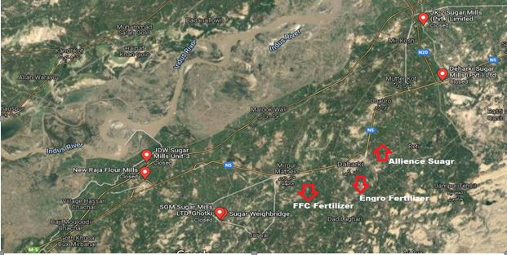

**Figure 1.** Sugar and fertilizer industries in the catchment of the Ghotki Feeder area



**Figure 2.** Flow diagram of methodology

**Table 1.** Industrial effluents disposal points and location of soil sampling

|  |  |  |  |  |
| --- | --- | --- | --- | --- |
| **Sr. No.** | **Name of the industries** | **Disposing points** | **GPS Location** | **Soil sampling outlet** |
| 1 | Alliance Sugar Mills Ltd. | Dahar minor | 28007’07’’N  69043’11’’E | 1-L |
| 2 | Daharki Sugar Mills Ltd. | Ghotki Feeder | 28009’45’’N  69036’33’’E | 1-AR |
| 3 | JKT Sugar Mills Ltd. | Thar minor | 28017’51’’N  69048’53’’E | 1-R |
| 4 | SGM Sugar Mills Ltd. | Qazi minor | 27047’59’’N  69025’60’’E | 2-L |
| 5 | JDW Sugar Mills Ltd. | Ghotki Feeder | 28009’45’’N  69036’33’’E | 2-R |
| 6 | Fauji Fertilizer Corporation | Qazi minor | 27047’59’’N  69025’60’’E | 3-AR |
| 7 | Engro Fertilizer Corporation | Mahi wah | 28016’02’’N  69046’34’’E | 4-AL |

**Water Sampling and Analysis:**

Water samples were collected from sugar and fertilizer industries before their discharge into the disposal sites. These samples were carefully collected in clean polyethylene bottles and subsequently analyzed at the laboratory of the Department of Land and Water Management, Faculty of Agricultural Engineering and Technology, Sindh Agriculture University, Tando Jam. The analysis procedures for each parameter were meticulously followed. Additionally, on-site measurements of temperature, pH value, and TDS were conducted and recorded. The pollution levels of the effluents were assessed by comparing them against the Food and Agriculture Organization [2].

**Physical parameters of water:**

**Temperature:**

The temperature of the wastewater was measured with a thermometer.

**Total dissolved solids:**

The Total Dissolved Solids (TDS) present in wastewater were determined by a TDS meter.

**pH value:**

The negative logarithm of the hydrogen ion concentration was measured by a digital pH meter.

**Electrical conductivity:**

The Electrical Conductivity (EC) of wastewater was determined by a digital EC meter.

**Total suspended solids:**

Total Suspended Solids (TSS) are determined by the following formula in mg/L:

TSS mg/L = $\frac{Weight \left(Final\right)g-Weight \left(Initial\right)g*1,000.00}{Sample Volume (mL)}$

Where:

TSS = Total suspended solids (mg L-1)

Weight (Final) = the weight of the filter plus the dried residue (g)

Weight (Initial) = the weight of the unused filter (g)

**Dissolved oxygen:**

Dissolved oxygen (DO) was measured by a dissolved oxygen meter, which is an electronic device that converts signals from a probe submerged in water into DO units in milligrams per liter. This procedure can also test the precision of the Winkler method for measuring dissolved oxygen levels in water samples.

**Biological oxygen demand**

Biological oxygen demand (BOD) of wastewater was determined by the standard method. BOD represents the amount of oxygen consumed by microorganisms during the breakdown of organic matter in the sample over the incubation period.

**Chemical oxygen demand**

There are several ways to estimate the chemical oxygen demand, including direct and indirect approaches. Frequently, samples that are analyzed using laboratory test procedures are used to determine the COD value. Using in-line process equipment, such as the Rhosonics Model 9585 COD meter, is the fastest way to measure COD. The following formula was used to determine the chemical oxygen demand.

COD = $\frac{8*1000*DF*M*(VB-Vs)}{Volume of sample (in ml)}$

Where:

DF = Dilution Factor (if applicable)

M = Molarity of standardized ferrous ammonium sulfate solution

VB = Volume consumed in titration with blank preparation.

Vs = Volume consumed in titration with sample preparation.

**Chloride:**

Most natural water sources contain chloride and sulfate ions. The determination of chloride in a natural or slightly alkaline solution is typically done through titration with standard silver nitrate, utilizing potassium chromate as an indicator. This method ensures that silver chloride is quantitatively precipitated before the formation of red silver chromate.

$$Chloride mg/L = \frac{\left(A-B\right)x N x 35.45 x 1000}{ml sample}$$

Where:

A = Ag NO3 required for sample (ml)

B = Ag NO3 required for blank (ml)

N = Normality of Ag NO3 used

**Sulfate:**

A spectrophotometer set at 420 nm or a nephelometer is used to measure the light absorbed or scattered by the precipitated slurry.

The following formula was used to determine the sulfate in wastewater.

SO4 (mg/L) = (Mass of BaSO4 (g) × 411.5) / Volume of sample (ml)

**Soil sampling and analysis:**

The soil samples were taken from the field located at the field outlets; details of the outlets are shown in Table 3.1. The samples were taken with the help of a spade at a depth of 0 - 60 cm. The Samples were analyzed for the EC, pH, SAR, and ESP in the Department of Land and Water Management, Faculty of Agricultural Engineering, Sindh Agriculture University, Tandojam.

**Sodium Concentrations of Soil:**

The sodium concentration in the soil was determined using a flame photometer. Soil samples were collected from different locations and air-dried, then sieved through a 2 mm mesh. A 1:5 soil-to-water extract was prepared by shaking the soil samples in distilled water for one hour. The extract was then filtered, and the sodium concentration was measured using the flame photometer according to standard procedures.

**Calcium and magnesium concentrations of soil:**

Calcium and magnesium concentrations were analyzed through titration with EDTA (Ethylene Diamine Tetra Acetic Acid). Soil samples were collected, dried, and sieved, then extracted using ammonium acetate. The extract was titrated with EDTA, and calcium and magnesium levels were determined by calculating the volume of EDTA used for each sample, following standard laboratory protocols.

**Sodium adsorption ratio of soil:**

The SAR was determined using the concentrations of sodium, calcium, and magnesium in the soil extract. The values obtained from the flame photometer for sodium and from titration for calcium and magnesium were used to calculate SAR using the following formula:

$$SAR=\frac{{Na}^{+}}{\sqrt{{({Ca}^{2+}+{Mg}^{2+})}/2}}$$

Where:

SAR = Sodium Absorption Ratio

Na = Sodium

Ca = Calcium

Mg = Magnesium

**Sulfate percentage of soil:**

Sulfate concentration in soil was determined using the turbidimetric method. Soil samples were extracted using a 0.01 M calcium chloride solution, and the extract was treated with barium chloride to form a precipitate. The turbidity was measured using a spectrophotometer at 420 nm, and sulfate concentration was determined by comparing the results with a standard sulfate curve.

**Boron percentage of soil:**

Boron content was analyzed using the hot water extraction method. Soil samples were boiled in distilled water for 5 minutes and filtered. The filtrate was treated with azomethine-H reagent, and boron concentration was measured using a spectrophotometer at 420 nm. The results were compared to a standard boron curve to determine the percentage of boron in the soil.

**Organic matter of soil:**

The Walkley-Black method was employed to determine the organic matter content in soil samples. In this procedure, potassium dichromate and sulfuric acid were used to oxidize the organic matter, and any excess dichromate was titrated using ferrous sulfate. Using established conversion factors, the amount of dichromate ingested was used to determine the proportion of organic matter.

**Results:**

**Physico-Chemical Parameters of Wastewater:**

Table 2 presents various physicochemical parameters of effluents discharged by different sugar and fertilizer industries into the waters of the Ghotki Feeder. The temperature of wastewater ranged from 24.10 to 27.13 degrees Celsius. The maximum wastewater temperature was recorded at Alliance Sugar Mills Ltd (27.13°C), followed by Daharki Sugar Mills Ltd (26.30°C), Fauji Fertilizer Corporation (25.93°C), JDW Sugar Mills Ltd. (24.66°C), Engro Fertilizer Corporation (25.63°C), SGM Sugar Mills Ltd. (25.13°C), with the minimum temperature observed at JKT Sugar Mills Ltd. (24.10°C). The temperature and conductivity values of wastewater at seven locations have fallen below the permissible limits set by FAO. The pH values of wastewater collected from different sources. The pH values ranged from 7.07 to 7.69 across various locations. The maximum pH value was recorded at JDW Sugar Mills Ltd (7.69), followed by SGM Sugar Mills Ltd (7.52), Engro Fertilizer Corporation (7.47), JKT Sugar Mills Ltd (7.38), Daharki Sugar Mills Ltd (7.23), and Alliance Sugar Mills Ltd (7.15). The minimum pH value was observed at Fauji Fertilizer Corporation (7.07). The pH values of wastewater at all seven locations exceeded the permissible limits set by FAO [2]. The total dissolved solids (TDS) in wastewater samples ranged from 934 to 2148 mg/L across various locations.

The highest TDS concentration was recorded at Daharki Sugar Mills Ltd (2148 mg/L), followed by JDW Sugar Mills Ltd (2080 mg/L), Fauji Fertilizer Corporation (1508 mg/L), Alliance Sugar Mills Ltd (1379 mg/L), JKT Sugar Mills Ltd (1256 mg/L), and Engro Fertilizer Corporation (1245 mg/L). The lowest TDS concentration was recorded at SGM Sugar Mills Ltd (934 mg/L). The TDS values of wastewater at all seven locations exceeded the permissible limits set by the FAO. The electrical conductivity (EC) of wastewater samples ranged from 2.32 to 6.08 dS/m across various locations. The highest EC was observed at Engro Fertilizer Corporation (6.08 dS/m), followed by Daharki Sugar Mills Ltd (5.88 dS/m), JKT Sugar Mills Ltd (5.65 dS/m), JDW Sugar Mills Ltd (3.46 dS/m), Fauji Fertilizer Corporation (3.14 dS/m), and SGM Sugar Mills Ltd (2.81 dS/m). The lowest EC was recorded at Alliance Sugar Mills Ltd (2.32 dS/m). The EC values of wastewater at all seven locations exceeded the permissible limits set by FAO.

The TSS in wastewater samples ranged from 1120 to 3557 ppm across various locations. The highest TSS was observed at Daharki Sugar Mills Ltd (3557 ppm), followed by SGM Sugar Mills Ltd (2886 ppm), JDW Sugar Mills Ltd (2286 ppm), JKT Sugar Mills Ltd (1688 ppm), Engro Fertilizer Corporation (1614 ppm), and Alliance Sugar Mills Ltd (1219 ppm). The lowest TSS was recorded at Fauji Fertilizer Corporation (1120 ppm). The TSS values of wastewater at all seven locations exceeded the permissible limits set by FAO. The dissolved oxygen (DO) levels in wastewater samples ranged from 0.18 to 0.34 mg/L across various locations. The highest DO concentration was observed at Engro Fertilizer Corporation (0.34 mg/L), followed by Fauji Fertilizer Corporation (0.31 mg/L), JDW Sugar Mills Ltd (0.28 mg/L), SGM Sugar Mills Ltd (0.25 mg/L), JKT Sugar Mills Ltd (0.22 mg/L), and Alliance Sugar Mills Ltd (0.2 mg/L). The lowest DO concentration was recorded at Daharki Sugar Mills Ltd (0.18 mg/L). The DO values of wastewater at all seven locations were lower than the permissible limits set by FAO. The biological oxygen demand (BOD) levels in wastewater samples ranged from 1604 to 4763 mg/L across various locations. The highest BOD concentration was observed at Engro Fertilizer Corporation (4763 mg/L), followed by Fauji Fertilizer Corporation (4228 mg/L), SGM Sugar Mills Ltd (3286 mg/L), JDW Sugar Mills Ltd (3258 mg/L), JKT Sugar Mills Ltd (2443 mg/L), and Daharki Sugar Mills Ltd (1930 mg/L).

**Table 2.** Physico-chemical parameters of wastewater taken from different mills

|  |  |  |  |  |  |  |  |  |  |  |
| --- | --- | --- | --- | --- | --- | --- | --- | --- | --- | --- |
| Location | Temperature (°C) | pH | TDS (mg/L) | EC (dS/m) | TSS (ppm) | DO (mg/L) | BOD (mg/L) | COD (mg/L) | Chloride (mg/L) | Sulfate (mmol/L) |
| Alliance Sugar Mills Ltd | 27.13 | 7.15 | 1379 | 2.32 | 1219 | 0.2 | 1604 | 20.66 | 567.33 | 9.5 |
| Daharki Sugar Mills Ltd | 26.3 | 7.23 | 2148 | 5.88 | 3557 | 0.18 | 1930 | 1.25 | 771.33 | 51.4 |
| Fauji Fertilizer Corporation | 25.93 | 7.07 | 1508 | 3.14 | 1120 | 0.31 | 4228 | 116.67 | 1770.7 | 57.06 |
| JDW Sugar Mills Ltd | 24.66 | 7.69 | 2080 | 3.46 | 2286 | 0.28 | 3258 | 105 | 1804.7 | 63.33 |
| Engro Fertilizer Corporation | 25.63 | 7.47 | 1245 | 6.08 | 1614 | 0.34 | 4763 | 215.67 | 2154 | 8 |
| SGM Sugar Mills Ltd | 25.13 | 7.52 | 934 | 2.81 | 2886 | 0.25 | 3286 | 118.33 | 1488 | 47.46 |
| JKT Sugar Mills Ltd | 24.1 | 7.38 | 1256 | 5.65 | 1688 | 0.22 | 2443 | 29.7 | 1303.7 | 30.36 |
| FAO Limits | 30.00 | 8.5 | 2000 | 3.00 | 1000 | 6.5 | 250 | 250 | 1000 | 20 |

The lowest BOD concentration was recorded at Alliance Sugar Mills Ltd (1604 mg/L). The BOD values of wastewater at all seven locations are lower than the permissible limits set by FAO. The COD levels in wastewater samples ranged from 1.25 to 215.67 mg/L across various locations. The highest COD concentration was observed at Engro Fertilizer Corporation (215.67 mg/L), followed by Fauji Fertilizer Corporation (116.67 mg/L), SGM Sugar Mills Ltd (118.33 mg/L), JDW Sugar Mills Ltd (105.00 mg/L), JKT Sugar Mills Ltd (29.70 mg/L), and Alliance Sugar Mills Ltd (20.66 mg/L). The lowest COD concentration was recorded at Daharki Sugar Mills Ltd (1.25 mg/L). The COD values of wastewater at all seven locations lowest the permissible limits. The chloride levels in wastewater samples ranged from 567.33 to 2154.0 mg/L across various locations. The highest chloride concentration was observed at Engro Fertilizer Corporation (2154.0 mg/L), followed by JDW Sugar Mills Ltd (1804.7 mg/L), Fauji Fertilizer Corporation (1770.7 mg/L), SGM Sugar Mills Ltd (1488.0 mg/L), JKT Sugar Mills Ltd (1303.7 mg/L), and Daharki Sugar Mills Ltd (771.33 mg/L). The lowest chloride concentration was recorded at Alliance Sugar Mills Ltd (567.33 mg/L). The chloride values of wastewater at all seven locations exceeded the permissible limits. The sulfate levels in wastewater samples ranged from 9.50 to 63.33 mmol/l across various locations. The highest sulfate concentration was observed at JDW Sugar Mills Ltd (63.33 mmol/l), followed by Fauji Fertilizer Corporation (57.06 mmol/l), Daharki Sugar Mills Ltd (51.40 mmol/l), SGM Sugar Mills Ltd (47.46 mmol/l), JKT Sugar Mills Ltd (30.36 mmol/l), and Alliance Sugar Mills Ltd (9.50 mmol/l). The lowest sulfate concentration was recorded at Engro Fertilizer Corporation (8 mmol/l). It's important to note that the sulfate values of both wastewater and groundwater at all seven locations exceeded the permissible limits.

**Physico-chemical parameters of irrigation water:**

**Physico-chemical parameters of irrigation water at Ghotki feeder:**

Table 3 presents the physicochemical parameters of irrigation water from the Ghotki Feeder. The assessment offers valuable insights into variations in water composition and their implications for agricultural irrigation. One of the most significant changes observed is in EC, which increased from 370 μS/cm before effluent discharge to 580 μS/cm after. This rise indicates increased salinity, which exceeds the FAO permissible limit of 0-300 μS/cm. Higher salinity levels can negatively impact soil permeability and plant growth, necessitating monitoring and mitigation measures. The concentration of calcium and magnesium also showed a slight increase, from 3.11 mg/L to 3.48 mg/L for both parameters. Despite the increase, calcium and magnesium levels remain within the FAO's acceptable limits—0–20 mg/L for calcium and 0–5 mg/L for magnesium, indicating no immediate concern for their use in irrigation water. A significant increase in Na concentration was observed, rising from 0.59 mg/L to 2.32 mg/L. Although this remains well within the FAO’s acceptable range of 0–40 mg/L, a sustained upward trend could eventually threaten soil structure and fertility. Similarly, sulfate **(**SO**₄)** levels significantly increased from 1.77 mg/L to 4.07 mg/L. Though still within the FAO threshold of 0-20 mg/L, this increase suggests a rise in dissolved solids that could contribute to soil salinity if not managed effectively. SAR, a critical indicator of water suitability for irrigation, increased from 0.47% to 1.76%. This rise suggests a higher risk of soil sodicity, although the value remains within the safe limit of 0-15%. Consistently monitoring SAR is essential to prevent potential soil degradation. In terms of alkalinity indicators, bicarbonate(HCO₄)levels slightly decreased from 0.83 mg/L to 0.56 mg/L, which remains well within the limit of 0-10 mg/L. No carbonates (CO₃) were detected before or after effluent discharge, aligning with the FAO standard of 0-0.1 mg/L. The pHvalue of irrigation water slightly decreased from 7.40 to 7.30 after effluent discharge. This slight variation remains within the FAO-recommended pH range of 6.0–8.5, indicating stable acidity levels that are suitable for irrigation purposes. A significant increase was observed in TSS, which rose from 237 ppm to 371 ppm. Although this increase suggests a higher load of suspended particles, the value remains well below the threshold of 1000 ppm. However, elevated TSS levels can contribute to sedimentation issues in irrigation infrastructure, necessitating regular maintenance of irrigation systems. The assessment of irrigation water at the Ghotki Feeder reveals notable changes in water quality following effluent discharge. The increase in electricalconductivity**,** sodium**,** andsulfatelevels suggests rising salinity, which could have long-term implications for soil health and crop productivity.

Although SAR and TSS levels have risen, they remain within acceptable limits. Similarly, calcium, magnesium, and chloride concentrations exhibit only minor fluctuations, indicating no immediate cause for concern. While the overall water quality remains within FAO permissible limit, regular monitoring is necessary to prevent further deterioration. Effective management strategies, such as regulated effluent discharge, enhanced drainage systems, and the use of soil amendments, can help mitigate potential risks and maintain the suitability of irrigation water for agriculture.

**Table 3.** Physico-chemical parameters of irrigation water at Ghotki feeder

|  |  |  |  |  |  |
| --- | --- | --- | --- | --- | --- |
| **Sr. No.** | **Parameter** | **Before effluent** | **After effluent** | **Increase / Decrease** | **FAO Limit** |
| 1 | EC (μS/cm) | 370.00 | 580.00 | -210.00 | 0-300 |
| 2 | Ca mg/L) | 3.11 | 3.48 | -0.37 | 0-20 |
| 3 | Mg (mg/L) | 3.11 | 3.48 | -0.37 | 0-5 |
| 4 | Na (mg/L) | 0.59 | 2.32 | -1.73 | 0-40 |
| 5 | CO4 (mg/L) | 0.00 | 0.00 | 0.00 | 0-0.1 |
| 6 | HCO4 (mg/L) | 0.83 | 0.56 | 0.27 | 0-10 |
| 7 | Cl (mg/L) | 1.10 | 1.17 | -0.07 | 0-30 |
| 8 | SO4 (mg/L) | 1.77 | 4.07 | -2.30 | 0-20 |
| 9 | SAR (%) | 0.47 | 1.76 | -1.29 | 0-15 |
| 10 | pH | 7.40 | 7.30 | 0.10 | 6.0-8.5 |
| 11 | TSS (ppm) | 237.00 | 371.00 | -134.00 | 1000 |

**Physico-chemical parameters of irrigation water at Dahar Minor:**

Table 4 shows the physico-chemical parameters of irrigation water at the Dahar minor. The irrigation water at Dahar Minor also exhibited significant changes following effluent discharge. EC exhibited a significant rise from 370 μS/cm to 1230 μS/cm, greatly surpassing the FAO’s recommended limit of 0–300 μS/cm. This drastic rise highlights severe salinity issues that could negatively impact soil structure and crop productivity. The levels of calcium and magnesium increased significantly, from 3.11 mg/L to 7.04 mg/L for both parameters. While these values remain within the FAO limit for calcium (0-20 mg/L), the magnesium level surpasses the threshold of 0-5 mg/L, which may lead to soil hardening and reduced water infiltration. The sodium (Na) concentration increased from 0.59 mg/L to 5.26 mg/L, which remains within the FAO limit of 0-40 mg/L. However, the rise in sodium levels suggests a trend toward increasing solidity, which could impair soil fertility in the long run. Additionally, sulfate (SO₄) levels increased dramatically from 1.77 mg/L to 10.07 mg/L, staying within the limit of 0-20 mg/L but indicating a significant rise in dissolved solids. Sodium Adsorption Ratio (SAR) also exhibited a notable increase, rising from 0.47% to 2.80%. Although within the FAO safe limit of 0-15%, this increase suggests that long-term use of this water for irrigation may lead to soil structural deterioration. Alkalinity indicators showed minor fluctuations, with bicarbonate (HCO₄)levels increasing slightly from 0.83 mg/L to 0.96 mg/L, staying within the limit of 0-10 mg/L. Chloride (Cl) levels saw a slight increase from 1.10 mg/L to 1.27 mg/L, remaining well within the limit of 0-30 mg/L. No detectable levels of carbonates (CO₄) were found before or after effluent discharge, which aligns with FAO guidelines. The pH level slightly decreased from 7.40 to 7.20, staying within the FAO [2] recommended range of 6.0-8.5, indicating no significant impact on water acidity. A major change was observed in TSS, which increased significantly from 237 ppm to 787 ppm.

While the value remains under the threshold of 1000 ppm, the notable increase points to a greater load of suspended particles, potentially leading to blockages in irrigation equipment and decreased flow efficiency. The drastic increase in electrical conductivity, sodium, and sulfate levels at Dahar Minor raises serious concerns regarding salinity buildup, which could threaten soil health and agricultural sustainability. Although SAR and TSS levels have risen, they remain within acceptable limits; however, continued monitoring is essential to prevent potential long-term impacts. The water at Dahar Minor exhibits alarming increases in EC, calcium, magnesium, sodium, and sulfate levels, indicating potential long-term soil degradation.

**Table 4.** Physico-chemical parameters of irrigation water at Dahar Minor

|  |  |  |  |  |  |
| --- | --- | --- | --- | --- | --- |
| **Sr. No.** | **Parameter** | **Before effluent** | **After effluent** | **Increase/Decrease** | **FAO Limit** |
| 1 | EC (μS/cm) | 370.00 | 1230.00 | -860.00 | 0-300 |
| 2 | Ca mg/L) | 3.11 | 7.04 | -3.93 | 0-20 |
| 3 | Mg (mg/L) | 3.11 | 7.04 | -3.93 | 0-5 |
| 4 | Na (mg/L) | 0.59 | 5.26 | -4.67 | 0-40 |
| 5 | CO4 (mg/L) | 0.00 | 0.00 | 0.00 | 0-0.1 |
| 6 | HCO4 (mg/L) | 0.83 | 0.96 | -0.13 | 0-10 |
| 7 | Cl (mg/L) | 1.10 | 1.27 | -0.17 | 0-30 |
| 8 | SO4 (mg/L) | 1.77 | 10.07 | -8.30 | 0-20 |
| 9 | SAR (%) | 0.47 | 2.80 | -2.33 | 0-15 |
| 10 | pH | 7.40 | 7.20 | 0.20 | 6.0-8.5 |
| 11 | TSS (ppm) | 237.00 | 787.00 | -550.00 | 1000 |

**Physico-chemical parameters of irrigation water at Thar Minor:**

Table 5 shows the physico-chemical parameters of irrigation water at Thar Minor. The irrigation water at Thar Minor displayed similar deteriorations in quality after effluent discharge. The **EC** increased significantly from 370 μS/cm to 1220 μS/cm, exceeding the FAO permissible limit. This rise suggests a considerable increase in dissolved salts, potentially leading to soil salinity issues. The levels of **calcium and magnesium** rose from 3.11 mg/L to 7.98 mg/L, exceeding the FAO limit for magnesium, which may result in soil infiltration issues. Similarly, **sodium (Na) concentration** increased from 0.59 mg/L to 4.22 mg/L, indicating a risk of sodicity over time. **Sulfate (SO₄) levels** experienced a drastic increase from 1.77 mg/L to 10.01 mg/L, which remains within the FAO limit but reflects a significant shift in water composition. **SAR** values also rose from 0.47% to 2.11%, indicating a growing risk of sodium accumulation in soils. The **pH level** slightly declined from 7.40 to 7.20, remaining within the acceptable range. A considerable increase in **TSS** from 237 ppm to 780 ppm suggests a higher presence of suspended particles, which may cause sedimentation issues in irrigation systems. The results from Thar Minor highlight significant changes in water quality due to effluent discharge. The most alarming concerns arise from the **increased salinity, sodium, and sulfate concentrations**, which could negatively impact soil productivity.

**Table 5.** Physico-chemical parameters of irrigation water at Thar Minor

|  |  |  |  |  |  |
| --- | --- | --- | --- | --- | --- |
| **Sr. No.** | **Parameter** | **Before effluent** | **After effluent** | **Increase/Decrease** | **FAO Limit** |
| 1 | EC (μS/cm) | 370.00 | 1220.00 | -850.00 | 0-300 |
| 2 | Ca mg/L) | 3.11 | 7.98 | -4.87 | 0-20 |
| 3 | Mg (mg/L) | 3.11 | 7.98 | -4.87 | 0-5 |
| 4 | Na (mg/L) | 0.59 | 4.22 | -3.63 | 0-40 |
| 5 | CO4 (mg/L) | 0.00 | 0.00 | 0.00 | 0-0.1 |
| 6 | HCO4 (mg/L) | 0.83 | 0.97 | -0.14 | 0-10 |
| 7 | Cl (mg/L) | 1.10 | 1.22 | -0.12 | 0-30 |
| 8 | SO4 (mg/L) | 1.77 | 10.01 | -8.24 | 0-20 |
| 9 | SAR (%) | 0.47 | 2.11 | -1.64 | 0-15 |
| 10 | pH | 7.40 | 7.20 | 0.20 | 6.0-8.5 |
| 11 | TSS (ppm) | 237.00 | 780.00 | -543.00 | 1000 |

**Physico-chemical parameters of irrigation water at Qazi Minor:**

Table 6 shows the physico-chemical parameters of irrigation water at Qazi Minor. The water quality assessment at Qazi Minor revealed a substantial deterioration after effluent discharge. The **EC** increased from 370 μS/cm to 1230 μS/cm, exceeding the FAO permissible limit, indicating severe salinity concerns. The levels of **calcium and magnesium** rose sharply from 3.11 mg/L to 8.74 mg/L, exceeding the FAO limit for magnesium. Similarly, **sodium (Na) concentration** increased from 0.59 mg/L to 3.56 mg/L, indicating potential risks of sodicity. **Sulfate (SO₄) levels** exhibited a significant rise from 1.77 mg/L to 10.42 mg/L, suggesting an increased concentration of dissolved solids. Meanwhile, **bicarbonate (HCO₄) levels** decreased from 0.83 mg/L to 0.37 mg/L, remaining within the FAO limit. The **SAR value** increased from 0.47% to 1.70%, indicating a higher sodium hazard for soil structure. TSS levels also showed a notable rise, increasing from 237 ppm to 787 ppm. While still below the FAO threshold, this indicates a substantial buildup of suspended particles. The most alarming concerns arise from the **increased salinity, sodium, and sulfate concentrations**, which could negatively impact soil productivity.

**Table 6.** Physico-chemical parameters of irrigation water at Qazi Minor

|  |  |  |  |  |  |
| --- | --- | --- | --- | --- | --- |
| **Sr. No.** | **Parameter** | **Before effluent** | **After effluent** | **Increase/Decrease** | **FAO Limit** |
| 1 | EC (μS/cm) | 370.00 | 1230.00 | -860.00 | 0-300 |
| 2 | Ca mg/L) | 3.11 | 8.74 | -5.63 | 0-20 |
| 3 | Mg (mg/L) | 3.11 | 8.74 | -5.63 | 0-5 |
| 4 | Na (mg/L) | 0.59 | 3.56 | -2.97 | 0-40 |
| 5 | CO4 (mg/L) | 0.00 | 0.00 | 0.00 | 0-0.1 |
| 6 | HCO4 (mg/L) | 0.83 | 0.37 | 0.46 | 0-10 |
| 7 | Cl (mg/L) | 1.10 | 1.51 | -0.41 | 0-30 |
| 8 | SO4 (mg/L) | 1.77 | 10.42 | -8.65 | 0-20 |
| 9 | SAR (%) | 0.47 | 1.70 | -1.23 | 0-15 |
| 10 | pH | 7.40 | 7.30 | 0.10 | 6.0-8.5 |
| 11 | TSS (ppm) | 237.00 | 787.00 | -550.00 | 1000 |

**Physico-chemical parameters of irrigation water at Mahi Wah:**

Table 7 shows the physico-chemical parameters of irrigation water at Mahi Wah. At Mahi Wah, the **EC** showed minimal change, increasing from 370 μS/cm to 380 μS/cm, remaining within the FAO limit. **Calcium and magnesium** slightly decreased from 3.11 mg/L to 3.01 mg/L, posing no significant concerns. **Sodium (Na) concentration** increased slightly from 0.59 mg/L to 0.79 mg/L, still well within the FAO limit. There was little variation in **sulfate (SO₄) levels,** increasing marginally from 1.77 mg/L to 1.82 mg/L. An increase in SAR from 0.47% to 0.64% was recorded, though it still falls within the FAO's safe range. Likewise, TSS rose slightly—from 237 ppm to 243 ppm—remaining comfortably below the permissible threshold. The most alarming concerns arise from the **increased salinity, sodium, and sulfate concentrations**, which could negatively impact soil productivity. Continuous monitoring and appropriate soil management practices are necessary to sustain agricultural viability.

**Physico-chemical parameters of soil:**

**Sodium concentrations of soil:**

Sodium concentration in soil samples taken from the command area of different mines is shown in Figure 3. The impact of wastewater on agricultural fields has been investigated, with a focus on soil sodium levels ranging from 4.7 to 13.5 mg/L. The results of this study indicate significant variations in sodium concentrations within the soil. The highest sodium concentration was observed in soil samples from Engro Fertilizer Corporation, measuring 13.5 mg/L, followed by SGM Sugar Mills Ltd at 13.1 mg/L, JKT Sugar Mills Ltd at 11 mg/L, Fauji Fertilizer Corporation at 10.4 mg/L, JDW Sugar Mills Ltd at 9.9 mg/L, and Daharki Sugar Mills Ltd at 7.8 mg/L. In contrast, the lowest sodium concentration in the soil was recorded at Alliance Sugar Mills Ltd, with a reading of 4.7 mg/L.

**Table 7.** Physico-chemical parameters of irrigation water at Mahi Wah

|  |  |  |  |  |  |
| --- | --- | --- | --- | --- | --- |
| **Sr. No.** | **Parameter** | **Before effluent** | **After effluent** | **Increase/Decrease** | **FAO Limit** |
| 1 | EC (μS/cm) | 370.00 | 380.00 | -10.00 | 0-300 |
| 2 | Ca mg/L) | 3.11 | 3.01 | 0.10 | 0-20 |
| 3 | Mg (mg/L) | 3.11 | 3.01 | 0.10 | 0-5 |
| 4 | Na (mg/L) | 0.59 | 0.79 | -0.20 | 0-40 |
| 5 | CO4 (mg/L) | 0.00 | 0.00 | 0.00 | 0-0.1 |
| 6 | HCO4 (mg/L) | 0.83 | 0.89 | -0.06 | 0-10 |
| 7 | Cl (mg/L) | 1.10 | 1.09 | 0.01 | 0-30 |
| 8 | SO4 (mg/L) | 1.77 | 1.82 | -0.05 | 0-20 |
| 9 | SAR (%) | 0.47 | 0.64 | -0.17 | 0-15 |
| 10 | pH | 7.40 | 7.40 | 0.00 | 6.0-8.5 |
| 11 | TSS (ppm) | 237.00 | 243.00 | -6.00 | 1000 |

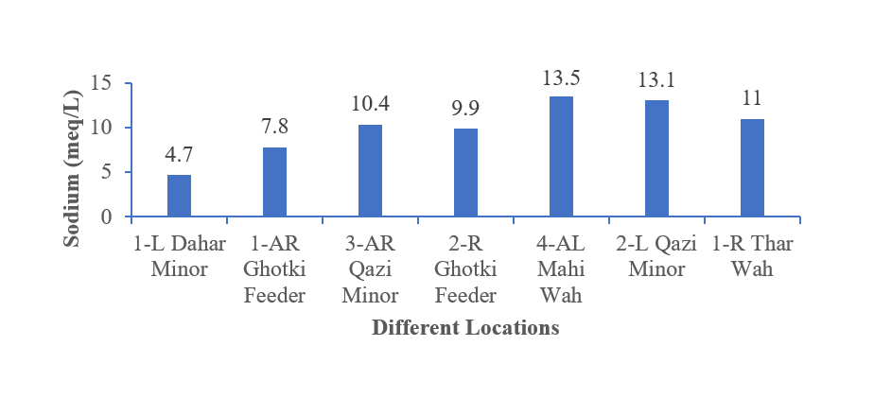

**Figure 3****.** Sodium concentrations of soil under different locations

**Calcium and magnesium concentration of soil:**

Figure 4 shows that the impact of wastewater on agricultural fields, specifically in terms of calcium and magnesium concentrations (mg/L), ranged from 10 to 58 mg/L. The results revealed considerable variations in the levels of these elements in the soil across the different locations: The highest combined calcium and magnesium concentration was observed in soil samples from Engro fertilizer corporation, measuring 56 mg/L, followed by SGM Sugar Mills Ltd at 58 mg/L, JKT Sugar Mills Ltd at 52 mg/L, Fauji Fertilizer Corporation at 39 mg/L, JDW Sugar Mills Ltd. at 32 mg/L, and Daharki Sugar Mills Ltd. at 22 mg/L. In contrast, the lowest calcium and magnesium concentration in the soil was recorded at Alliance Sugar Mills Ltd, with a reading of 10 mg/L.

**Sodium adsorption ratio of soil:**

SAR of different soil samples is demonstrated in Figure 5. The results revealed that effects of wastewater on agricultural fields were examined by examining the soil SAR within the range of 2.1 to 2.6, respectively. The results revealed significant variations in soil parameters across the different sampling locations. The highest SAR value was observed in soil samples from Engro Fertilizer Corporation, with a SAR of 2.6, followed by SGM Sugar Mills Ltd at 2.4, JKT Sugar Mills Ltd at 2.2, Fauji Fertilizer Corporation at 2.4, JDW Sugar Mills Ltd. at 2.5, and Daharki Sugar Mills Ltd. at 2.4. Conversely, the lowest SAR value was recorded at Alliance Sugar Mills Ltd, with a SAR of 2.1.

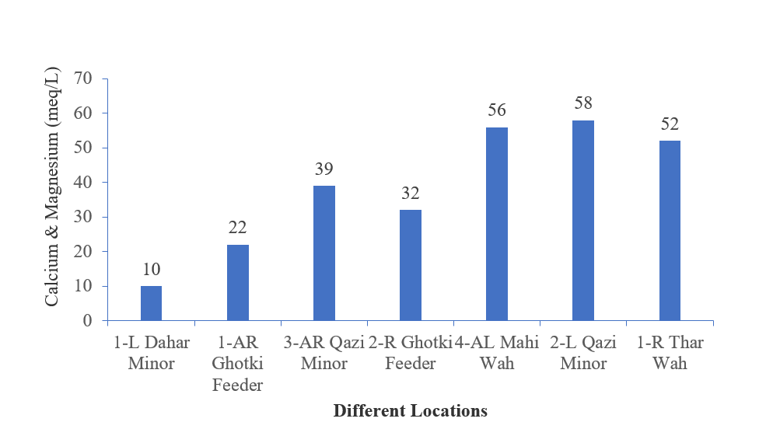

**Figure 4****.** Calcium and Magnesium concentrations of soil under different locations

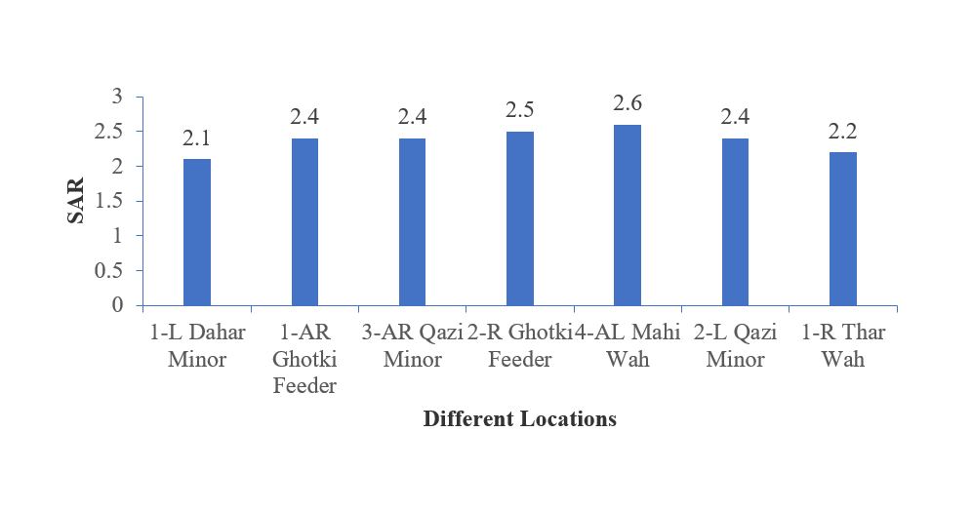

**Figure 5****.** Sodium adsorption ratio of soil under different locations

**Sulfate percentage of soil:**

Figure 6 shows the sulphate % in the soil samples to determine the impact of wastewater on agricultural fields. The percentage of sulfate (SO4 %) in the soil was analyzed and ranged from 0.002 to 0.013%. The findings illustrate the varying sulfate concentrations in the soil across the different locations: The highest sulfate content was observed in soil samples from Alliance Sugar Mills Ltd., with a sulfate percentage of 0.013%, followed by Engro Fertilizer Corporation at 0.010%, Fauji Fertilizer Corporation at 0.009%, Daharki Sugar Mills Ltd. at 0.011%, JKT Sugar Mills Ltd. at 0.005%, SGM Sugar Mills Ltd. at 0.004%, and JDW Sugar Mills Ltd. at 0.002%.

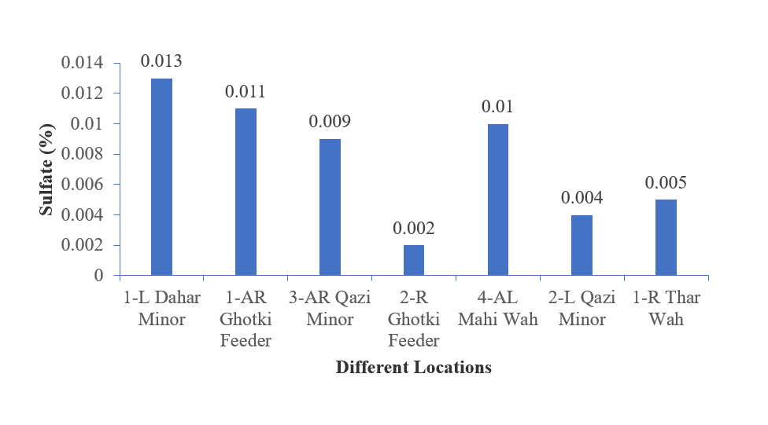

**Figure 6****.** Sulfate percentage of soil under different locations

**Boron percentage of soil:**

Under the experiment, the impact of wastewater on agricultural fields was checked by knowing the percentage of boron (Boron% %) in the soil as given in Figure 7. The boron percentages ranged from 0.13% to 0.28% across the various locations, revealing distinct variations in soil boron concentrations. The highest boron percentage was observed in soil samples from SGM Sugar Mills Ltd., with a boron percentage of 0.28%. It was followed by Fauji Fertilizer Corporation at 0.27%, JKT Sugar Mills Ltd. at 0.22%, Engro Fertilizer Corporation at 0.26%, JDW Sugar Mills Ltd. at 0.21%, Daharki Sugar Mills Ltd. at 0.20%, and Alliance Sugar Mills Ltd. at 0.13%.

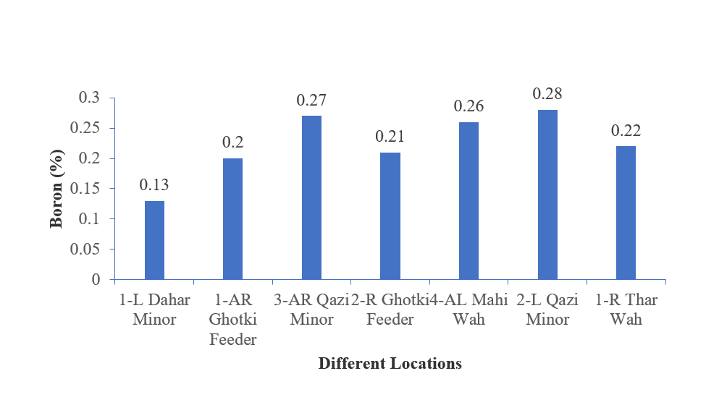

**Figure 7****.** Boron percentage of soil under different locations

**Organic Matter of Soil:**

Figure 8 shows the impact of wastewater on agricultural fields in terms of the percentage of organic matter (OM%) in the soil. The organic matter percentages ranged from 0.21% to 0.56% across the different locations, showcasing variations in soil organic matter content:

Soil samples from Alliance Sugar Mills Ltd., Daharki Sugar Mills Ltd., and Engro Fertilizer Corporation showed the highest organic matter content, each recording 0.56%. JDW Sugar Mills Ltd. followed with 0.42%, while both SGM Sugar Mills Ltd. and JKT Sugar Mills Ltd. had the lowest values at 0.21%.

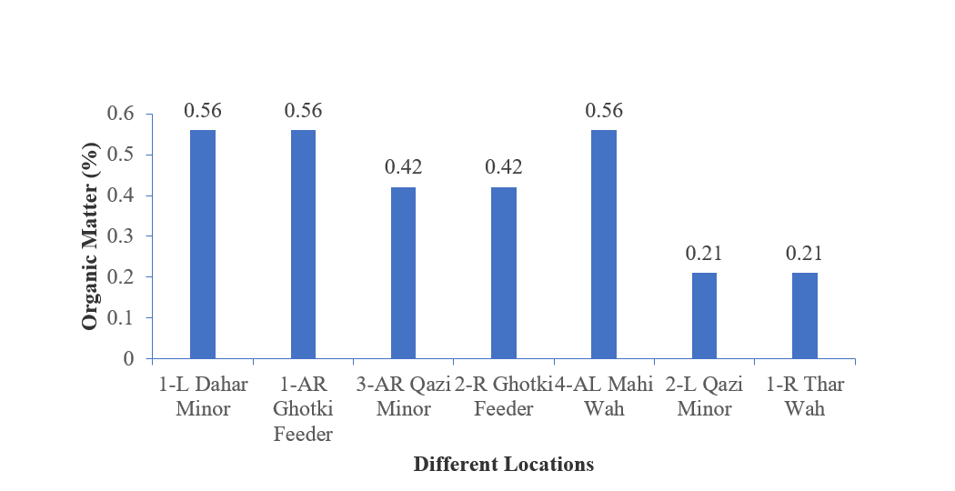

**Figure 8****.** Organic matter of soil under different locations

**Discussions:**

**Impact of effluents on the water of the Ghotki feeder:**

Water is a gift from nature, and it is often assumed that, despite the amount of fresh water accessible on the planet, many places are experiencing water shortages as a result of pollution caused by human activity [3]. Rapid population growth, urbanization, and unregulated water use have contributed to the continuous decline of both groundwater and surface water resources. Groundwater is the primary source of drinking water in much of Pakistan. In rural regions, manual pumps and electric motor pumps are the most prevalent instruments for extracting groundwater. However, in several regions of Sindh province, the quality of groundwater is notably poor, raising concerns about its suitability for human consumption. In areas lacking proper filtration facilities, people are compelled to consume contaminated water. This deterioration in water quality and availability has led to a rise in waterborne diseases transmitted through unsafe drinking water [4]. As a result, the current study was conducted to analyze the drinking as well as irrigation water situation in the command area of the Ghotki feeder. Wastewater samples were collected from sugar and fertilizer industries on the Ghotki feeder and agricultural fields for this purpose. The study findings indicate that the maximum temperature of wastewater was recorded at Alliance Sugar Mills Ltd, while the minimum temperature was observed at JKT Sugar Mills Ltd. JDW Sugar Mills Ltd exhibited the highest pH value in wastewater, whereas the lowest pH value was detected at Fauji Fertilizer Corporation. Daharki Sugar Mills Ltd. had the highest total dissolved solids concentration, while SGM Sugar Mills Ltd had a lower concentration. Engro Fertilizer Corporation showed the highest electrical conductivity, with Alliance Sugar Mills Ltd having the lowest. The maximum total suspended solids were found at Daharki Sugar Mills Ltd, and the minimum at Fauji Fertilizer Corporation.

Engro Fertilizer Corporation had the highest dissolved oxygen content, while Daharki Sugar Mills Ltd had the lowest. The peak biological oxygen demand was recorded at Engro Fertilizer Corporation. However, the minimum biological oxygen demand of wastewater was determined from Alliance Sugar Mills Ltd. The maximum chemical oxygen demand of wastewater was determined by Engro Fertilizer Corporation. However, the minimum chemical oxygen demand of wastewater was determined from Daharki Sugar Mills Ltd. The results show that the maximum chloride concentration of wastewater was determined from the Engro Fertilizer Corporation. However, the minimum chloride of wastewater was determined from Alliance Sugar Mills Ltd. Maximum sulfate of wastewater was determined from JDW Sugar Mills Ltd. However, the minimum sulfate of wastewater was determined by the Engro Fertilizer Corporation. The pH of wasted wash collected from distilleries was found to be between 3.3 and 3.9 [5], which is in close agreement with the current study's findings. In contrast to the current findings, [6] discovered that distillery effluents had a pH between 3.8 and 4.5, which was comparatively less acidic. The distillery effluent's low pH is caused by a larger concentration of organic acids, such as CH3COOH, which are produced during the biochemical conversion of highly biodegradable organic matter and are brought on by high BOD and COD loading [7]. The pH of sugar process effluent was determined to be 4.35 by [8], which was comparable to the current study's findings. However, the usage of sulphur dioxide and phosphoric acid during the purification of sugar cane juice may have contributed to the acidity of effluent from sugar manufacturing [8].

Large amounts of acidic wastewater were released from SCOUL, which was the cause of the downstream river water's acidic character. The organic spills of molasses and juice from sugar production, as well as distillery wash from fermented molasses, may have contributed to the high levels of chemical oxygen demand (COD) and biochemical oxygen demand (BOD). Due to a large load of oxygen-consuming organic pollutants released into the river and a notable increase (p = 0.004) in the temperature of the contaminated river water, the average DO concentration downstream along the river Musamya decreased from 6.5 ± 0.3 to 2.8 ± 0.3 mg/L. This is consistent with research by [9], which discovered that oxygen solubility reduces as temperature rises and that effluent with high BOD and COD speeds up bacterial growth in rivers, lowering dissolved oxygen levels.

**Effect of effluents on agricultural fields:**

The impact of wastewater on agricultural fields, particularly soil sodium levels, is a significant concern due to its potential implications for soil health and crop production, with a focus on soil sodium levels ranging from 4.7 to 13.5 mg/L. These values correspond to the research of [10], who found the sodium concentration of soil ranges between 11 to 30 mg/L after wastewater irrigation. [11] Using wastewater for irrigation can introduce contaminants, including sodium, which can negatively affect soil structure and plant growth. [12] showed that the sodium content in wastewater is crucial, as different sources of wastewater can have varying levels. High sodium levels can contribute to soil salinity, which can negatively affect plant growth by impeding water uptake.

Wastewater's impact on agricultural fields, especially in terms of calcium and magnesium concentrations, which ranged from 10 to 58 mg/L, is crucial for soil and water management. These findings also agree with the research of [10], which reported the calcium and magnesium concentrations of 1.12 to 10.16 mg/L. These nutrients are essential for plant growth and can significantly affect crop health and productivity. Another study found that wastewater with high concentrations is used for irrigation, it provides these elements to plants, contributing to soil alkalinity, neutralizing acidity, and improving pH levels [13]. Soil sodium adsorption ratio (SAR) is a crucial parameter in soil science that assesses the impact of sodium on soil structure and permeability, considering its concentration relative to calcium and magnesium, assessing the risk of soil dispersion and sodicity. In a study examining wastewater's effects on agricultural fields, SAR values within the range of 2.1 to 2.6 were found, likely associated with the impact of wastewater on the soil. SAR values typically range from 0 to a higher number, with higher values indicating a higher concentration of sodium relative to calcium and magnesium. These findings align with the observations reported by [14]. The use of wastewater in agriculture can negatively impact soil quality and contribute to the accumulation of heavy metals in plants [15]. However, treated wastewater can alter the soil's chemical and physical characteristics. A 20-year application of treated wastewater raises the levels of heavy metals and lowers the acidity of agricultural soils, according to [16]. The growth and nutrition supply of plants may be impacted by increased wastewater levels. Additionally, it can raise the pH, EC, and SAR of the soil, which might raise the salinity of the soil. The analysis of sulfate percentages in soil is crucial for understanding the impact of wastewater on agricultural fields. Sulfate, a common component of wastewater used for irrigation, can affect soil chemistry and crop growth.

The range of sulfate percentages, from 0.002% to 0.013%, indicates the amount of sulfate present in the soil. Sulfate levels can contribute to soil acidity, which can be detrimental to certain crops and may require lime application to maintain pH levels. The experiment examined the impact of wastewater on agricultural fields, focusing on the percentage of boron in the soil. The results showed that soil boron concentrations varied across different locations, with the highest concentration found. The use of treated effluent as a supplementary irrigation water source has significant potential in industrial water zones. However, more attention should be given to effluent quality, especially for Boron-sensitive crops. For example, citrus in southern Florida was irrigated with 0.31 mg/L treated effluent for over 10 years [17], resulting in an annual increase of 4.6 mg B/kg dry weight in leaves. However, leaf B concentrations are still below toxic levels. Long-term use of treated effluent is limited by salinity and Boron concentration. For example, in Murcia, Spain, treated effluent with 1.4 and 221 mg/L Boron and chloride concentrations are limiting values for lemon irrigation [18]. The study examines the impact of wastewater on agricultural fields and the percentage of organic matter in soil.

The result shows the organic matter percentages across the different locations, showcasing variations in soil organic matter content. These results are very close to studies conducted by [19], [20], and [21] have collectively shown a significant increase in organic matter percentage in soil following irrigation with treated wastewater. This increase in organic matter content has been associated with improvements in soil structure and fertility. Furthermore, the studies suggest that the increase in organic matter is positively correlated with the intensity of wastewater irrigation, with higher irrigation levels resulting in greater benefits to the soil. Additionally, irrigation with wastewater has been found to increase organic carbon (OC) percentage and total carbon (TC) content, contributing to soil health improvement. Moreover, [19] observed an increase in hydrophobicity in subsoil following wastewater irrigation. Furthermore, a statistically significant correlation between pollution indices and soil characteristics, including pH and organic matter content, was found in experimental data gathered by [22].

**Conclusions:**

The effluents of sugar and fertilizer industries located in district Ghotki, polluted the water of Ghotki feeder, in terms of temperature, total dissolved solids, pH, electrical conductivity, total suspended solids, dissolved oxygen, biological oxygen demand, chemical oxygen demand, chloride, and sulphate. The polluted water of Ghotki feeder, through Dahar wah, Thar wah, Qazi wah, and Mahi wah, polluted the soils of district Ghotki in terms of sodium, calcium, magnesium, sodium absorption ratio, sulphate, boron, and organic matter.

**References:**

[1] M. A. Imran, A. Ali, M. Ashfaq, S. Hassan, R. Culas, and C. Ma, “Impact of Climate Smart Agriculture (CSA) Practices on Cotton Production and Livelihood of Farmers in Punjab, Pakistan,” *Sustain. 2018, Vol. 10, Page 2101*, vol. 10, no. 6, p. 2101, Jun. 2018, doi: 10.3390/SU10062101.

[2] “(PDF) FAO Irrigation and Drainage Paper 33.” Accessed: Aug. 02, 2025. [Online]. Available: https://www.researchgate.net/publication/259842050_FAO_Irrigation_and_Drainage_Paper_33

[3] I. Delpla, A.-V. Jung, E. Baures, M. Clement, and O. Thomas, “Impacts of climate change on surface water quality in relation to drinking water production,” *Environ. Int.*, vol. 35, no. 8, pp. 1225–1233, 2009, doi: https://doi.org/10.1016/j.envint.2009.07.001.

[4] S. C. Shaikh Yasmeen Asgarsab, “Assessment of Water Quality in Some Biodegradable and Non-Biodegradable Substrates Added Periphyton Systems,” *Int. J. Sci. Res.*, vol. 4, no. 10, pp. 217–219, 2015, [Online]. Available: https://www.researchgate.net/publication/322292026_Assessment_of_Water_Quality_in_Some_Biodegradable_and_Non-Biodegradable_Substrates_Added_Periphyton_Systems

[5] S. K. Gupta, S. K. Gupta, and G. Singh, “Anaerobic hybrid reactor: A promising technology for treatment of distillery spent wash,” *Int. J. Environ. Pollut.*, vol. 43, no. 1–3, pp. 221–235, 2010, doi: 10.1504/IJEP.2010.035926;PAGE:STRING:ARTICLE/CHAPTER.

[6] S. C. Suhuttaya Jiranuntipon, Marie-Line Delia, Claire Albasi, Somsak Damronglerd, “Decolourization of molasses based distillery wastewater using a bacterial consortium,” *Sci. Asia*, 2009, [Online]. Available: https://www.scienceasia.org/content/viewabstract.php?ms=2358

[7] Wioleta Mikucka & Magdalena Zielińska, “Distillery Stillage: Characteristics, Treatment, and Valorization,” *Appl. Biochem. Biotechnol.*, vol. 192, pp. 770–793, 2020, doi: https://doi.org/10.1007/s12010-020-03343-5.

[8] A. S. Kailas M. Doke, Ejazuddin M Khan, Joseph Rapolu, “Physico-Chemical Analysis of Sugar Industry Effluent and Its Effect on Seed Germination of Vigna angularis, Vigna cylindrical and Sorghum cernum,” *Ann. Environ. Sci.*, vol. 5, 2011, [Online]. Available: https://openjournals.neu.edu/aes/journal/article/view/v5art2

[9] M. Salequzzaman, M., Tariqul, I. S. M., Tasnuva, A., Kashem, M. A. & Mahedi Al Masud, “Environmental impact of sugar industry: A case study on Kushtia sugar mills in Bangladesh: Khulna,” *j. innov.dev.strategy*, vol. 2, no. 3, pp. 31–35, 2008, [Online]. Available: https://ggfjournals.com/assets/uploads/31-35.pdf

[10] B. F. F. Pereira, Z. He, P. J. Stoffella, C. R. Montes, A. J. Melfi, and V. C. Baligar, “Nutrients and Nonessential Elements in Soil after 11 Years of Wastewater Irrigation,” *J. Environ. Qual.*, vol. 41, no. 3, pp. 920–927, May 2012, doi: 10.2134/JEQ2011.0047;PAGE:STRING:ARTICLE/CHAPTER.

[11] D. H. Andrew Poustie, Yu Yang, Paul Verburg, Krishna Pagilla, “Reclaimed wastewater as a viable water source for agricultural irrigation: A review of food crop growth inhibition and promotion in the context of environmental change,” *Sci. Total Environ.*, vol. 739, p. 139756, 2020, doi: https://doi.org/10.1016/j.scitotenv.2020.139756.

[12] M. Elgallal, L. Fletcher, and B. Evans, “Assessment of potential risks associated with chemicals in wastewater used for irrigation in arid and semiarid zones: A review,” *Agric. Water Manag.*, vol. 177, pp. 419–431, 2016, doi: https://doi.org/10.1016/j.agwat.2016.08.027.

[13] S. B. L. Salar Rezapour, Amin Nouri, Hawzhin M. Jalil, Shawn A. Hawkins, “Influence of Treated Wastewater Irrigation on Soil Nutritional-Chemical Attributes Using Soil Quality Index,” *Sustainability*, vol. 13, no. 4, p. 1952, 2021, doi: https://doi.org/10.3390/su13041952.

[14] S. Z. Maryam Saffari Aman, Mohammad Jafari, Majid Karimpour Reihan, Babak Motesharezadeh, “Assessing the effect of industrial wastewater on soil properties and physiological and nutritional responses of Robinia pseudoacacia, Cercis siliquastrum and Caesalpinia gilliesii seedlings,” *J. Environ. Manage.*, vol. 217, pp. 718–726, 2018, doi: https://doi.org/10.1016/j.jenvman.2018.03.087.

[15] W. J. Bond, “Effluent irrigation—an environmental challenge for soil science,” *Soil Res.*, vol. 36, no. 4, pp. 543–556, 1998, doi: 10.1071/S98017.

[16] J. Y. Yintao Lu, Hong Yao, Dan Shan, Yichen Jiang, Shichao Zhang, “Heavy Metal Residues in Soil and Accumulation in Maize at Long-Term Wastewater Irrigation Area in Tongliao, China,” *J. Chem.*, 2015, doi: https://doi.org/10.1155/2015/628280.

[17] A. J. M. B.F.F. Pereira, Z.L. He, P.J. Stoffella, “Reclaimed wastewater: Effects on citrus nutrition,” *Agric. Water Manag.*, vol. 98, no. 12, pp. 1828–1833, 2011, doi: https://doi.org/10.1016/j.agwat.2011.06.009.

[18] C. Fritzmann, J. Löwenberg, T. Wintgens, and T. Melin, “State-of-the-art of reverse osmosis desalination,” *Desalination*, vol. 216, no. 1–3, pp. 1–76, 2007, doi: https://doi.org/10.1016/j.desal.2006.12.009.

[19] M. A. A. T.P. Abegunrin, G.O. Awe, D.O. Idowu, “Impact of wastewater irrigation on soil physico-chemical properties, growth and water use pattern of two indigenous vegetables in southwest Nigeria,” *Catena*, vol. 139, pp. 167–178, 2016, doi: https://doi.org/10.1016/j.catena.2015.12.014.

[20] A. A. Alrajhi, S. Beecham, Nanthi S. Bolan, Hassanli, “Evaluation of soil chemical properties irrigated with recycled wastewater under partial root-zone drying irrigation for sustainable tomato production,” *Agric. Water Manag.*, vol. 161, pp. 127–135, 2015, doi: https://doi.org/10.1016/j.agwat.2015.07.013.

[21] J. He, M. Dougherty, F. J. Arriaga, and A. H. AbdelGadir, “Impact of a real-time controlled wastewater subsurface drip disposal system on the selected chemical properties of a vertisol,” *Environ. Technol.*, vol. 34, no. 10, pp. 1341–1347, 2013, doi: 10.1080/09593330.2012.746737.

[22] I. K. Kalavrouziotis, P. H. Koukoulakis, D. Papaioannou, and A. Mehra, “pH and organic matter impact on the indices of soil metal load assessment under wastewater and biosolid reuse,” *J. Chem. Technol. Biotechnol.*, vol. 93, no. 11, pp. 3244–3253, Nov. 2018, doi: 10.1002/JCTB.5683;PAGEGROUP:STRING:PUBLICATION.

|  |  |
| --- | --- |
| Image result for CC BY | Copyright © by the authors and 50Sea. This work is licensed under the Creative Commons Attribution 4.0 International License. |