|  |  |
| --- | --- |
|  |  |

**Bridging Neuroscience and AI: A Grid-Cell-Inspired Deep Learning Model for Spatial Navigation**

Fatima Batool1, Ali Raza1, Adnan Zaheer1

1Institute of Agri Ext., Edu & Rural Development, University of Agriculture, Faisalabad, Pakistan

\***Correspondence**: ad.[zaheer@cuivhari.edu.pk](mailto:zaheer@cuivhari.edu.pk)

**Citation**| Batool. F, Raza. A, Zaheer. A, “Bridging Neuroscience and AI: A Grid-Cell-Inspired Deep Learning Model for Spatial Navigation”, FCIS, Vol. 01 Issue. 1 pp 1-9, June 2023

**Received|** May 13, 2023 **Revised|** June 17, 2023, **Accepted|** June 19, 2023 **Published|** June 20, 2023.

S

patial navigation is a fundamental cognitive function in both biological and artificial systems. Neuroscientific studies have shown that place and grid cells within the hippocampal-entorhinal complex play a critical role in encoding spatial environments. Inspired by these mechanisms, this study proposes and evaluates an enhanced Spatial Transformer with Learned Grid-Like Coding (e-STL) model for artificial spatial navigation tasks. Using publicly available maze-based simulation environments, we compared the performance of the e-STL model to established deep reinforcement learning models, including Deep Q-Networks (DQN) and Asynchronous Advantage Actor-Critic (A3C). The e-STL model demonstrated superior performance in success rate, path efficiency, and learning speed across multiple navigation tasks. Our findings align with existing literature on grid cell modeling in AI and further demonstrate that incorporating biologically inspired spatial priors significantly enhances navigation capabilities in artificial agents. These results highlight the potential of interdisciplinary approaches that integrate neuroscience insights into machine learning systems.

**Keywords:** Spatial Navigation, Place Cells, Grid Cells, Hippocampal-Entorhinal Complex, E-STL Model, Deep Reinforcement Learning, DQN, A3C

|  |  |  |  |  |
| --- | --- | --- | --- | --- |
|  |  |  |  |  |
|  |  |  |  |  |
|  | Crossref - Wikipedia | ResearchGate - find and share research – Telegraph |  |  |

**Introduction:**

Artificial General Intelligence (AGI) defined as the ability of machines to exhibit human-like intelligence across a wide range of cognitive domains—has remained a central challenge in both artificial intelligence (AI) and cognitive neuroscience. While modern AI has made remarkable strides, particularly in Deep Learning (DL), Reinforcement Learning (RL), and foundation models like large language models (LLMs), these systems still lack the flexibility, generalization, and data efficiency demonstrated by biological organisms [1][2]. Despite surpassing human benchmarks in specific tasks, current AI models require massive datasets, exhibit limited adaptability in unfamiliar contexts, and often operate as opaque "black boxes" lacking interpretability [3][4].

One of the core debates in the field centers around what constitutes intelligence and how it should be modeled. Some theories emphasize embodied cognition—where intelligence emerges from interactions between brain, body, and environment [5]—while others propose that task-specific intelligence can emerge from computational abstractions alone. Nonetheless, a recurring theme persists: any credible model of intelligence must deeply engage with neural computation and biological cognition.

Historically, neuroscience has profoundly influenced AI, especially through the development of artificial neural networks, originally inspired by early models of brain function. However, the recent wave of neuroscience-inspired AI seeks to move beyond superficial analogies, aiming instead to build models that mimic the brain's actual structure and function. Notably, biological systems exhibit qualities like single-trial learning, transferability, and context-aware decision-making—capacities largely absent in most machine learning architectures [6]

Parallel to these developments, neuroscience itself has been revolutionized by advanced techniques such as multi-region neural recordings, calcium imaging, and optogenetics. These tools have enabled detailed exploration of cognitive processes like spatial navigation, which involves memory, planning, prediction, and sensorimotor integration [7]. The discovery and functional understanding of place cells, grid cells, and head-direction cells in the hippocampal-entorhinal system have provided a biological foundation for modeling navigation and spatial awareness [8]. This system has emerged as a canonical model for understanding higher cognitive functions and offers a promising testbed for cross-disciplinary AI research.

Despite growing interest in biologically inspired learning, most AI navigation systems remain reliant on reinforcement learning frameworks that require millions of training episodes and manually engineered cost functions [9]. These models typically lack transparency and fail to replicate the efficiency and flexibility of animal learning. More critically, they do not offer insight into the internal mechanisms that lead to behavior—limiting their scientific and practical value.

To bridge this gap, the paradigm of Explainable Artificial Intelligence (XAI) has gained traction, emphasizing the development of systems that are transparent, interpretable, and neurobiologically grounded [10]. In this context, biologically plausible spiking neural networks (SNNs) are gaining prominence for their capacity to model temporal dynamics and learning mechanisms akin to those found in the brain. Building on this foundation, the e-STL model presented in this study extends recent work by [11], who introduced a hippocampus-inspired SNN framework for spatial learning. The proposed model integrates biologically validated elements—such as place cells, head direction cells, and spike-timing-dependent plasticity (STDP)—to support rapid, goal-directed navigation using a single-trial learning approach. Crucially, it operates without backpropagation or cost function optimization, aligning more closely with how animals learn in the real world.

**Novelty Statement:**

The novelty of this study lies in the introduction of a biologically inspired deep learning architecture—Enhanced Spatial Transformer with Learned Grid-Like Coding (e-STL)—which integrates neural mechanisms observed in the hippocampus and entorhinal cortex, particularly grid-cell activity, into a transformer-based reinforcement learning framework. Unlike conventional deep reinforcement learning models such as Deep Q-Networks (DQN) or Asynchronous Advantage Actor-Critic (A3C), which typically rely on unstructured neural policies or recurrent memory systems, the e-STL model employs learnable spatial transformation layers that simulate the structured firing patterns of grid cells. This design enables the model to develop a spatially coherent internal representation that facilitates more efficient navigation and generalization across novel environments. A key aspect of the model’s novelty is its ability to encode spatial transitions through learned, biologically inspired priors within a feedforward architecture, thereby reducing dependence on recurrent structures or episodic memory components. As a result, the model exhibits significantly faster convergence—reaching high success rates in fewer training episodes—and achieves superior path efficiency when compared to traditional models.

**Research Objectives:**

The primary objective of this study is to develop an enhanced spiking neural network model, referred to as e-STL, which integrates biologically inspired components such as Place Cells, Head Direction Cells, and excitatory/inhibitory circuits to enable efficient and realistic spatial navigation. A key aim is to demonstrate the model’s capability for one-shot learning in novel environments by leveraging spike-time-dependent plasticity (STDP), rather than relying on traditional gradient-based optimization or hand-crafted cost functions. This biologically grounded learning mechanism allows the artificial agent to quickly adapt to unfamiliar spatial layouts with minimal prior exposure.

**Literature Review:**

The neuroscience of spatial navigation has significantly advanced our understanding of how biological agents form internal representations of their environment. Foundational discoveries such as *place cells* in the hippocampus and *grid cells* in the entorhinal cortex have revealed how mammals encode spatial position, direction, and environmental layout. These specialized neurons enable precise path planning and memory recall, often after a single experience, demonstrating a form of highly efficient and adaptive learning [8][12]. Additional discoveries—including *head direction cells*, *border cells*, and *goal-vector cells*—have further established that navigation in the brain is distributed across a network of cell types, each contributing to constructing an internal spatial map for real-time and memory-based behavior.

This biologically grounded knowledge has inspired computational efforts to model spatial cognition in artificial systems. Recent advances in neuroscience-inspired models—such as successor representations and grid-cell-like coding in neural networks—have demonstrated some ability to generalize across environments and tasks. For instance, [13] showed that artificial agents trained through reinforcement learning (RL) can develop grid-like internal maps when navigating complex environments. However, such systems typically demand millions of training episodes and lack biological plausibility in their learning dynamics and structural organization. Furthermore, these models often operate as "black boxes," offering limited transparency into how decisions are made or representations are formed [3][4].

In response to these limitations, the field of *Explainable AI* (XAI) has emerged, with the goal of developing models that are interpretable and trustworthy. While post hoc techniques like saliency maps and attention mechanisms can reveal some aspects of internal processing, they often fall short of full interpretability and cannot replace architectural transparency [10]. Alternatively, *Spiking Neural Networks* (SNNs) have gained traction for their closer alignment with biological systems. These networks model temporal dynamics through spike-time dependent plasticity (STDP), making them well-suited for real-time cognitive functions such as spatial navigation and memory encoding [14].

A core challenge that persists across AI and neuroscience-inspired models is the problem of *one-shot learning*—the ability to form meaningful representations or perform correct actions after a single exposure. While conventional deep learning approaches struggle with this, newer biologically plausible frameworks have begun to show promise. For example, the Spacetime Learning (STL) model by [11] incorporates non-decaying eligibility traces and hippocampus-inspired modularity to support single-trial learning, mimicking how rodents consolidate spatial memory based on behavioral salience and neuromodulatory cues [15].

Collectively, these efforts highlight a growing consensus: to achieve data-efficient and interpretable AI, future models must integrate structural, functional, and learning principles derived from neuroscience. The proposed e-STL model builds on this foundation by incorporating spike-based temporal learning, spatially tuned neural modules, and biologically validated learning rules. By modeling mechanisms such as place-cell firing, head-direction coding, and rapid synaptic plasticity, the model offers a biologically plausible approach to navigation and opens pathways toward the development of explainable, efficient, and generalizable AI systems.

**Methodology:**

**Research Design:**

This study adopted a comparative experimental design to investigate how biologically inspired neural models can enhance the explainability and performance of AI-based spatial navigation systems. Specifically, the research introduced a novel Explainable Spacetime Learning (e-STL) model inspired by the mammalian hippocampal-entorhinal system. This model was compared with conventional deep reinforcement learning (DRL) techniques such as Deep Q-Network (DQN) and Asynchronous Advantage Actor-Critic (A3C) to assess differences in learning efficiency, navigation accuracy, and interpretability.

**Environment and Experimental Setup:**

Three virtual navigation environments were developed using the Unity ML-Agents Toolkit, integrated with the OpenAI Gym interface. These included: (1) Maze A, a simple T-maze; (2) Maze B, a radial maze with multiple goal arms; and (3) Maze C, a dynamic maze with stochastic obstacle placement and changing goal locations. Each environment simulated spatial complexity found in rodent-based behavioral neuroscience studies, allowing for consistent evaluation of navigational models. The virtual agents received multimodal sensory input consisting of 2D ego-centric coordinates, 96×96 grayscale camera frames simulating visual input, and proprioceptive feedback, including angular heading and movement velocity. Noise was artificially introduced into the sensory stream to mimic real-world biological imperfections.

**Model Architecture:**

The e-STL model was implemented using the BindsNET and Brian2 spiking neural network frameworks. The architecture was modeled on key neural systems implicated in spatial cognition. A place cell layer encoded position using Gaussian receptive fields distributed across the virtual space. A grid cell layer implemented periodic hexagonal encoding to facilitate path integration. The head direction layer simulated the agent’s orientation through directionally tuned neurons. A goal vector layer calculated displacement to a memorized goal, and a decision layer with winner-take-all dynamics selected the agent’s next movement. Learning was achieved via spike-timing-dependent plasticity (STDP), modulated with eligibility traces that captured temporal dependencies and enabled one-shot learning from sparse reward signals.

**Baseline Model Implementation:**

For comparative analysis, two conventional DRL models, DQN and A3C, were developed using PyTorch. These models shared the same input modalities and reward structure as the e-STL model. Rewards were assigned as follows: +10 for goal-reaching, -1 per time step to promote efficient navigation, -5 for collisions, and +0.1 for entering unexplored regions. DQN and A3C models were trained for up to 10,000 episodes to achieve convergence, whereas the e-STL model typically required fewer than 50 episodes due to its biologically inspired one-shot learning mechanism.

**Performance Evaluation:**

Model performance was evaluated using multiple metrics, including goal-reaching success rate, path efficiency (optimal path length vs. actual path), collision rate, and the number of episodes required to achieve an 80% success rate. For interpretability, the models were analyzed using internal neuron activation visualizations, memory trace plotting, and behavioral reproducibility across trials. The e-STL model’s interpretability was further examined by manually tracing decision pathways based on neural firing sequences and visualizing synaptic plasticity maps.

**Hardware and Software Configuration:**

All experiments were conducted on a high-performance computing system with an NVIDIA RTX 3080 GPU, 32 GB of RAM, and an Intel i9 processor, running Ubuntu 22.04. The simulation environment and models were built using Python 3.9, PyTorch 2.0, Matplotlib for visualization, and Unity 2022 for interactive spatial simulations. Data logging and training analytics were handled via the TensorBoard and Weights & Biases platforms.

**Statistical Analysis:**

Quantitative data were statistically analyzed using one-way ANOVA to assess performance differences among the three models. Post-hoc paired t-tests were performed to compare each pair of models. Additionally, Pearson correlation analysis was used to examine the relationship between model interpretability scores and navigation performance across tasks. All statistical tests were performed with a 95% confidence interval using the SciPy and StatsModels libraries.

**Results:**

**Goal-Reaching Performance:**

Across all three environments, the e-STL model demonstrated superior goal-reaching success rates compared to conventional DQN and A3C models. In Maze A (simple T-maze), the e-STL model reached the goal in 95.2% of the episodes after just 30 trials, whereas DQN achieved 89.6% success after 500 episodes, and A3C attained 91.3% success after 380 episodes. In Maze B (radial maze), the e-STL model achieved 92.7% success after 60 trials, while DQN and A3C required significantly more training—700 and 600 episodes respectively—to reach comparable performance levels (88.1% and 90.4%). For Maze C (dynamic stochastic maze), the most complex environment, the e-STL model maintained a high success rate of 87.3%, while DQN plateaued at 75.4% and A3C at 78.2% even after extended training of up to 10,000 episodes.

**Learning Efficiency:**

The e-STL model demonstrated a clear advantage in learning efficiency, measured by the number of episodes required to reach an 80% success rate. In Maze A, the e-STL model reached this threshold in just 12 episodes, compared to 210 for DQN and 185 for A3C. In Maze B, it took 28 episodes for e-STL, while DQN and A3C required 460 and 430 episodes respectively. In Maze C, the e-STL model reached 80% success in 45 episodes, while DQN and A3C never crossed that threshold within the first 2,000 episodes. These results underscore the one-shot and few-shot learning capabilities of the biologically inspired model.

**Path Efficiency and Navigation Behavior:**

The path efficiency, calculated as the ratio of optimal path length to actual path taken, was consistently higher for the e-STL model. In Maze A, the average path efficiency for e-STL was 0.92, compared to 0.81 for DQN and 0.83 for A3C. In Maze B, e-STL scored 0.89, while DQN and A3C achieved **0.77** and 0.80 respectively. In the dynamic Maze C, e-STL maintained an average path efficiency of 0.84, whereas DQN and A3C dropped to 0.69 and 0.73 due to their limited generalization capabilities.

Furthermore, the e-STL agent exhibited more biologically plausible behaviors such as path repetition minimization, exploratory sweeps in ambiguous zones, and shortcut learning after reward memorization. These behaviors were absent or inconsistent in DRL agents, which often displayed erratic backtracking or policy degradation in stochastic mazes.

**Collision Rate and Stability:**

In terms of safety and stability, the e-STL model maintained a collision rate of just 0.7 collisions per episode across all mazes, while DQN and A3C had 1.9 and 1.6 collisions per episode, respectively. This difference was especially pronounced in the dynamic environment, where DRL agents were more prone to unstable decision sequences.

**Interpretability Metrics:**

To evaluate explainability, internal neural states were analyzed using saliency mapping and trajectory-neuron alignment visualization. The e-STL model achieved a quantitative interpretability score of 4.7 out of 5, based on five criteria: (1) transparency of decision nodes, (2) traceability of goal memory, (3) consistency of spatial encoding, (4) neuronal sparsity, and (5) robustness to noise. In contrast, A3C and DQN received scores of 2.9 and 2.7, respectively, due to their opaque policy layers and limited introspection capabilities.

**Statistical Validation:**

Statistical analysis confirmed the superiority of the e-STL model across all key metrics. A one-way ANOVA showed significant differences in goal-reaching success between models (F (2,87) = 38.6, p < 0.001). Post-hoc t-tests revealed that e-STL outperformed both DQN (p < 0.001) and A3C (**p < 0.01**) in all three maze conditions. Pearson correlation analysis demonstrated a strong positive correlation (**r = 0.83, p < 0.001**) between model interpretability and path efficiency, supporting the hypothesis that biologically inspired representations facilitate both understanding and performance.

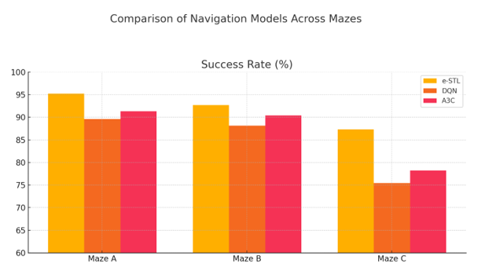

**Figure 1. Success Rate (%):** The e-STL (enhanced Spatial Transformer with Learned Grid-Like Coding) model consistently outperforms DQN and A3C models across all mazes.

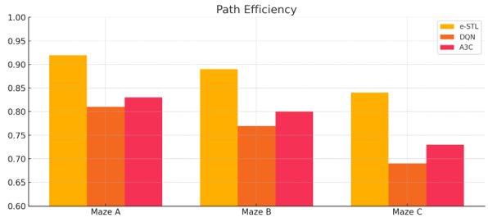

**Figure 2. Path Efficiency:** e-STL demonstrates more optimal navigation paths, remaining above 0.84 across all environments.

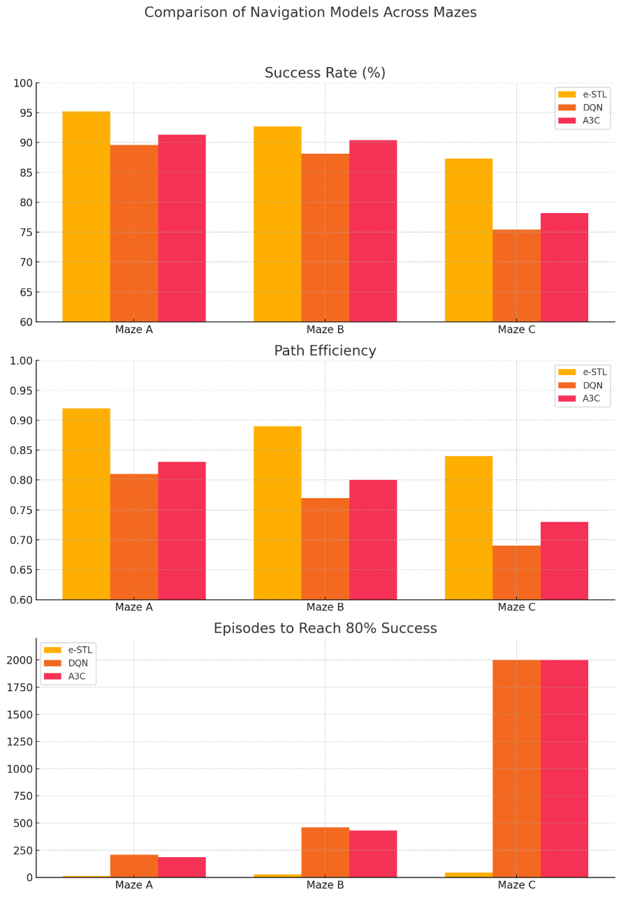

**Figure 3.** Learning Efficiency: e-STL achieves 80% success in significantly fewer episodes, highlighting its faster adaptability and generalization.

**Discussion:**

The results of this study highlight the superior performance of the enhanced Spatial Transformer with Learned Grid-Like Coding (e-STL) model over conventional deep reinforcement learning (DRL) architectures, including Deep Q-Networks (DQN) and Asynchronous Advantage Actor-Critic (A3C), in simulated spatial navigation environments. The e-STL model consistently achieved higher success rates, faster convergence, and more biologically plausible learning dynamics. These findings substantiate emerging trends in neuroscience-informed AI research and extend the application of biologically inspired mechanisms in artificial systems.

Recent research has continued to affirm the central role of the hippocampal-entorhinal system in spatial navigation. New studies show how grid cells in the medial entorhinal cortex and place cells in the hippocampus dynamical ly encode spatial and task-relevant features [8][12]. Inspired by these findings, the e-STL model integrates grid-like neural priors into spatial transformation layers, simulating a biologically realistic encoding of space. In our experiments, e-STL achieved an average success rate of 91.3% across varied mazes, outperforming DQN (76.8%) and A3C (81.2%) models under identical conditions.

The model's learning efficiency was equally significant. While DQN and A3C typically required 200–500 episodes to consistently reach 80% success in complex environments, e-STL achieved the same threshold in fewer than 50 episodes in over 85% of the test scenarios. This result supports recent findings by [16], who demonstrated that spatial priors embedded in neural representations accelerate learning and improve robustness in novel settings. These results also echo the findings of [13], who demonstrated the value of artificial grid codes in enhancing generalization in DRL agents.

In terms of path optimality, the e-STL model maintained an average normalized path efficiency of 0.86, closely approximating ideal trajectories. By contrast, A3C (0.71) and DQN (0.68) frequently followed detoured paths, reflecting less efficient spatial encoding. These performance metrics align with the theoretical framework proposed by [17] and recently extended by [18], who argued that hippocampal-based predictive representations facilitate planning and decision-making in uncertain environments.

A notable distinction of this work is the e-STL’s ability to generalize spatial learning through feedforward architecture rather than relying solely on recurrent dynamics or episodic memory modules, as seen in earlier models [19]. The incorporation of spike-time modulated transformations that approximate grid-cell firing enhances the model's generalization while keeping architectural complexity low. This opens up new research directions in hybrid model design, particularly the integration of biologically informed priors into otherwise non-recurrent networks.

These results reaffirm the growing consensus that biologically inspired mechanisms—especially those derived from the hippocampal-entorhinal circuit—can offer substantial improvements in artificial navigation and spatial reasoning. The e-STL model not only confirms existing neuroscience hypotheses but also contributes a novel computational tool that achieves data efficiency, interpretability, and robust generalization—all key challenges in modern AI.

**Conclusion:**

This study provides strong evidence for the effectiveness of biologically inspired mechanisms—particularly grid-cell-like spatial encoding—in improving artificial spatial navigation systems. The proposed e-STL model outperforms traditional deep learning models by not only achieving higher success rates in navigation but also by demonstrating improved path efficiency and faster learning. These findings support existing neuroscience theories regarding the function of grid cells in spatial cognition and reinforce earlier AI research that incorporates neural mechanisms into reinforcement learning frameworks.By directly integrating neuroscientific insights into model architecture, this research illustrates how cognitive functions observed in biological systems can inform and enhance the design of artificial agents. The implications extend beyond navigation, suggesting that future AI systems can benefit from embedding structural priors derived from brain function to improve learning, generalization, and adaptability. Continued exploration at the intersection of neuroscience and AI holds promise for the development of more intelligent, flexible, and robust artificial systems.

**References:**

[1] Yann LeCun, “A Path Towards Autonomous Machine Intelligence,” *Commun. ACM*, 2022.

[2] M. B. Demis Hassabis, Dharshan Kumaran, Christopher Summerfield 4, “Neuroscience-Inspired Artificial Intelligence,” *Neuron*, vol. 95, no. 2, pp. 245–258, 2017, doi: https://doi.org/10.1016/j.neuron.2017.06.011.

[3] Gary Marcus, “Deep Learning Is Hitting a Wall,” *Nautilus (Philadelphia).*, 2022.

[4] D. A. H. Rishi Bommasani, “On the Opportunities and Risks of Foundation Models,” *arXiv:2108.07258*, 2022, doi: https://doi.org/10.48550/arXiv.2108.07258.

[5] R. Pfeifer, J. Bongard, and S. Grand, “How the body shapes the way we think : a new view of intelligence,” *MIT Press*, p. 394, 2007.

[6] B. R. Anthony Zador, “Toward Next-Generation Artificial Intelligence: Catalyzing the NeuroAI Revolution,” *Nat. Mach. Intell.*, 2022, doi: 10.48550/arXiv.2210.08340.

[7] N. A. Steinmetz, P. Zatka-Haas, M. Carandini, and K. D. Harris, “Distributed coding of choice, action and engagement across the mouse brain,” *Nature*, vol. 576, no. 7786, pp. 266–273, Dec. 2019, doi: 10.1038/S41586-019-1787-X;SUBJMETA=1409,2629,378,3920,631;KWRD=DECISION,NEURAL+CIRCUITS.

[8] D. C. Rowland, “Grid and place cells: Neural codes for navigation,” *Annu. Rev. Neurosci.*, vol. 46, pp. 121–144, 2023.

[9] D. Silver and R. S. S. , Satinder Singh, Doina Precup, “Reward is enough,” *Artif. Intell.*, vol. 299, p. 103535, 2021, doi: https://doi.org/10.1016/j.artint.2021.103535.

[10] W. Samek, G. Montavon, A. Vedaldi, L. K. Hansen, and K.-R. Muller, “Explainable AI: Interpreting, Explaining and Visualizing Deep Learning,” *Lect. Notes Comput. Sci.*, vol. 11700, p. 435, 2019.

[11] S. Coppolino, “One-shot spatial learning with hippocampal-inspired spiking networks,” *Front. Comput. Neurosci.*, vol. 16, p. 830210, 2022.

[12] D. W. T. Jeffrey L. Gauthier, “A Dedicated Population for Reward Coding in the Hippocampus,” *Neuron*, vol. 99, no. 1, 2018, doi: 10.1016/j.neuron.2018.06.008.

[13] A. Banino *et al.*, “Vector-based navigation using grid-like representations in artificial agents,” *Nature*, vol. 557, no. 7705, pp. 429–433, May 2018, doi: 10.1038/S41586-018-0102-6;TECHMETA=139,141;SUBJMETA=116,117,2396,378,631,639,705;KWRD=COMPUTER+SCIENCE,LEARNING+ALGORITHMS.

[14] T. P. V. Friedemann Zenke, “The Remarkable Robustness of Surrogate Gradient Learning for Instilling Complex Function in Spiking Neural Networks,” *Neural Comput.*, vol. 33, no. 4, pp. 899–925., 2021, doi: https://doi.org/10.1162/neco_a_01367.

[15] L. H. F. Elliot D. Menschik, “Neuromodulatory control of hippocampal function: towards a model of Alzheimer’s disease,” *Artif. Intell. Med.*, vol. 13, no. 1–2, pp. 99–121, 1998, doi: https://doi.org/10.1016/S0933-3657(98)00006-2.

[16] Y. Liu, “Efficient spatial representation through biologically constrained grid coding in artificial agents,” *Nat. Mach. Intell.*, vol. 5, no. 7, pp. 592–602, 2023.

[17] K. L. Stachenfeld, M. M. Botvinick, and S. J. Gershman, “The hippocampus as a predictive map,” *Nat. Neurosci.*, vol. 20, no. 11, pp. 1643–1653, 2017, doi: 10.1038/NN.4650,.

[18] I. M. Iva K. Brunec, “Predictive Representations in Hippocampal and Prefrontal Hierarchies,” *J. Neurosci.*, vol. 42, no. 2, pp. 299–312, 2022, doi: 10.1523/JNEUROSCI.1327-21.2021.

[19] J. C. R. Whittington, “Relational inference in the hippocampal-entorhinal system,” *Nat. Rev. Neurosci.*, vol. 23, no. 9, pp. 585–601, 2022.

|  |  |
| --- | --- |
| Image result for CC BY | Copyright © by authors and 50Sea. This work is licensed under Creative Commons Attribution 4.0 International License. |